Experiment No:-
Name: Bhagyashree Rajgonda Patil Roll No: 27
Class: MCA SY Semester: 3rd
Subject: Mobile Application Development Batch: M2
Q) Design and implement an Android application using Android Studio that demonstrates the use of various Android Views
1) List View

- Activity_main.xml
<?xml version="1.0" encoding="utf-8"?>
<LinearLayout xmlns:android="http://schemas.android.com/apk/res/android" xmlns:app="http://schemas.android.com/apk/res-auto" android:orientation="vertical" android:layout_width="match_parent" android:layout_height="match_parent">

<androidx.appcompat.widget.Toolbar android:layout_width="match_parent" android:layout_height="?attr/actionBarSize" android:background="?attr/colorPrimary" android:elevation="4dp" android:theme="@style/ThemeOverlay.AppCompat.ActionBar"
app:title="List View" app:titleTextColor="@android:color/white"/>

<!-- ListView --> <ListView android:id="@+id/listView" android:layout_width="match_parent" android:layout_height="match_parent" />
</LinearLayout>

List_item.xml

<?xml version="1.0" encoding="utf-8"?>
<LinearLayout xmlns:android="http://schemas.android.com/apk/res/android" android:orientation="vertical" android:padding="12dp" android:layout_width="match_parent" android:layout_height="wrap_content">

<TextView android:id="@+id/name" android:textSize="18sp" android:textStyle="bold" android:layout_width="wrap_content" android:layout_height="wrap_content" android:text="Name" />

<TextView android:id="@+id/designation" android:textSize="16sp" android:layout_width="wrap_content" android:layout_height="wrap_content" android:text="Designation" />

<TextView android:id="@+id/location" android:textSize="14sp" android:layout_width="wrap_content" android:layout_height="wrap_content" android:text="Location" />

ListItem.java

package com.examples.listview;
public class ListItem { private String name; private String designation; private String location;
// Getters and setters

public String getName() { return name;
}

public void setName(String name) {
this.name = name;
}
public String getDesignation() { return designation;
}

public void setDesignation(String designation) { this.designation = designation;
}
public String getLocation() { return location;
}
public void setLocation(String location) { this.location = location;
}
}

CustomListAdapter.java

package com.examples.listview;
import android.app.Activity;
import android.view.LayoutInflater; import android.view.View;
import android.view.ViewGroup; import android.widget.ArrayAdapter; import android.widget.TextView;
import java.util.ArrayList;
public class CustomListAdapter extends ArrayAdapter<ListItem> {
private final Activity context;
private final ArrayList<ListItem> users;
public CustomListAdapter(Activity context, ArrayList<ListItem> users) { super(context, R.layout.list_item, users);
this.context = context;
this.users = users;
}
static class ViewHolder { TextView name;
TextView designation;
TextView location;
}

@Override
public View getView(int position, View convertView, ViewGroup parent) {
ViewHolder holder;
View rowView = convertView;
if (rowView == null) {
LayoutInflater inflater = context.getLayoutInflater(); rowView = inflater.inflate(R.layout.list_item, null, true);

holder = new ViewHolder();
holder.name = rowView.findViewById(R.id.name); holder.designation = rowView.findViewById(R.id.designation); holder.location = rowView.findViewById(R.id.location);
rowView.setTag(holder);
} else {
holder = (ViewHolder) rowView.getTag();
}
ListItem item = users.get(position); holder.name.setText(item.getName()); holder.designation.setText(item.getDesignation()); holder.location.setText(item.getLocation());
return rowView;
}
}

MainActivity.java

package com.examples.listview;
import android.os.Bundle;
import android.view.View;
import android.widget.AdapterView; import android.widget.ListView; import android.widget.Toast;
import com.examples.listview.ListItem;
import androidx.appcompat.app.AppCompatActivity;
import java.util.ArrayList;
public class MainActivity extends AppCompatActivity {
ListView listView;
@Override protected void onCreate(Bundle savedInstanceState) { super.onCreate(savedInstanceState); setContentView(R.layout.activity_main);
listView = findViewById(R.id.listView);
// Get data from method
ArrayList<ListItem> users = getListData();

// Create adapter with your custom ListItem list
CustomListAdapter adapter = new CustomListAdapter(this, users);

// Set adapter to ListView listView.setAdapter(adapter);

// Handle list item click events listView.setOnItemClickListener((AdapterView<?> parent, View view, int position, long id) -> {
ListItem selectedUser = users.get(position);
String message = "Selected: " + selectedUser.getName() + ", "
+ selectedUser.getDesignation() + ", "
+ selectedUser.getLocation();
Toast.makeText(getApplicationContext(), message, Toast.LENGTH_SHORT).show();
});
}

// Prepare sample data
private ArrayList<ListItem> getListData() {
ArrayList<ListItem> results = new ArrayList<>();

ListItem user1 = new ListItem(); user1.setName("Sanika"); user1.setDesignation("Software Developer"); user1.setLocation("Mumbai"); results.add(user1);

ListItem user2 = new ListItem(); user2.setName("Shravani"); user2.setDesignation("UI/UX Designer"); user2.setLocation("Pune"); results.add(user2);

ListItem user3 = new ListItem(); user3.setName("Bhagyashree"); user3.setDesignation("Data Analyst"); user3.setLocation("Hyderabad");
results.add(user3);
ListItem user4 = new ListItem(); user4.setName("Sony");
user4.setDesignation("Project Manager"); user4.setLocation("Bangalore");
results.add(user4);

ListItem user5 = new ListItem(); user5.setName("Saba"); user5.setDesignation("QA Engineer"); user5.setLocation("Delhi"); results.add(user5);
return results;
}
}

Output:
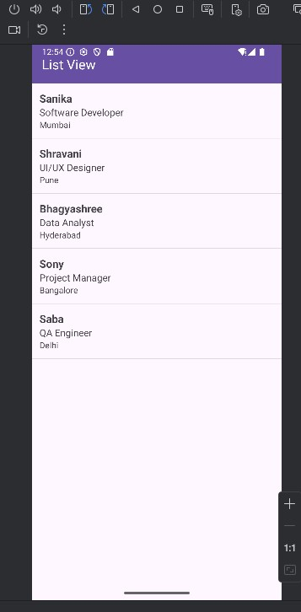

Web View
- Activity_main.xml

<?xml version="1.0" encoding="utf-8"?>
<LinearLayout xmlns:android="http://schemas.android.com/apk/res/android" xmlns:app="http://schemas.android.com/apk/res-auto" xmlns:tools="http://schemas.android.com/tools" android:layout_width="match_parent" android:layout_height="match_parent" android:orientation="vertical" tools:context=".MainActivity">

<!-- Toolbar at the top -->
<androidx.appcompat.widget.Toolbar android:id="@+id/toolbar" android:layout_width="match_parent" android:layout_height="?attr/actionBarSize" android:background="?attr/colorPrimary" android:elevation="4dp" android:theme="@style/ThemeOverlay.AppCompat.Dark.ActionBar" app:title="My Web Page" app:titleTextColor="@android:color/white" />

<!-- WebView below the toolbar -->
<WebView android:id="@+id/webView" android:layout_width="match_parent" android:layout_height="0dp" android:layout_weight="1" />
</LinearLayout>

- Mainactivity.java

package com.examples.webview;
import android.os.Bundle;
import android.webkit.WebSettings;
import android.webkit.WebView;
import android.webkit.WebViewClient;
importandroidx.appcompat.app.AppCompatActivty;
public class MainActivity extends AppCompatActivity {
private WebView webView;
@Override protected void onCreate(Bundle savedInstanceState) { super.onCreate(savedInstanceState); setContentView(R.layout.activity_main);

webView = findViewById(R.id.webView);

// Enable JavaScript
WebSettings webSettings = webView.getSettings(); webSettings.setJavaScriptEnabled(true);

// Load URL inside the WebView webView.setWebViewClient(new WebViewClient()); webView.loadUrl("https://www.example.com");
}
// Handle back button to go back in WebView history
@Override public void onBackPressed() { if (webView.canGoBack()) { webView.goBack();
} else {
super.onBackPressed();
}
}

• OUTPUT:
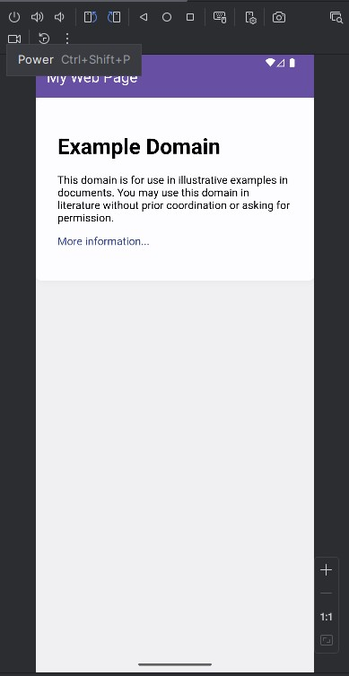

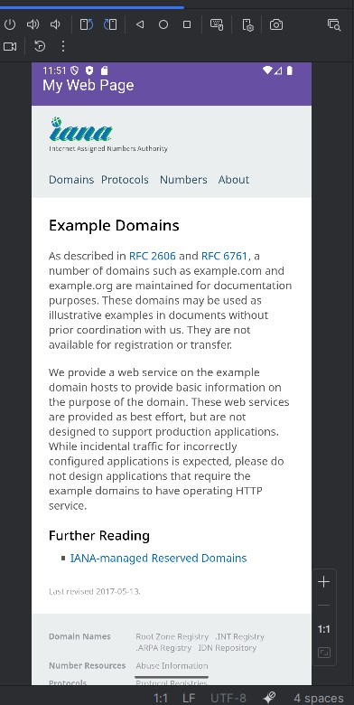

- Grid View

- Activitymain.xml

<?xml version="1.0" encoding="utf-8"?>
<LinearLayout xmlns:android="http://schemas.android.com/apk/res/android" xmlns:app="http://schemas.android.com/apk/res-auto" android:layout_width="match_parent" android:layout_height="match_parent" android:orientation="vertical" android:background="#FFF6FD">

<!-- Toolbar -->
<androidx.appcompat.widget.Toolbar android:id="@+id/toolbar" android:layout_width="match_parent" android:layout_height="?attr/actionBarSize" android:background="?attr/colorPrimary" android:elevation="4dp" android:theme="@style/ThemeOverlay.AppCompat.Dark.ActionBar"
app:title="Grid View" android:layout_marginTop="20dp" app:titleTextColor="@android:color/white" /> <!-- GridView --> <GridView android:id="@+id/gridView" android:layout_width="match_parent" android:layout_height="0dp" android:layout_weight="1" android:layout_marginTop="50dp" android:background="#FFF6FD" android:columnWidth="140dp" android:numColumns="auto_fit" android:verticalSpacing="16dp" android:horizontalSpacing="16dp" android:padding="16dp" android:gravity="center" android:stretchMode="columnWidth" />

</LinearLayout>

- Mainactivity.java

package com.example.gridview;

import android.content.Intent;
import android.os.Bundle;
import android.view.View;
import android.widget.AdapterView;
import android.widget.GridView;

import androidx.appcompat.app.AppCompatActivity;

public class MainActivity extends AppCompatActivity {

@Override protected void onCreate(Bundle savedInstanceState) { super.onCreate(savedInstanceState); setContentView(R.layout.activity_main);

GridView gv = (GridView) findViewById(R.id.gridView); gv.setAdapter(new ImageAdapter(this)); gv.setOnItemClickListener(new AdapterView.OnItemClickListener() { public void onItemClick(AdapterView<?> parent, View v, int position, long id) { Intent i = new Intent(getApplicationContext(), FullImageActivity.class);
i.putExtra("id", position); startActivity(i);
}
});

}
}
- FullImageActivity.java

package com.example.gridview;

import android.app.Activity;
import android.content.Intent;
import android.os.Bundle;
import android.widget.ImageView;

public class FullImageActivity extends Activity {
@Override public void onCreate(Bundle savedInstanceState) { super.onCreate(savedInstanceState);
setContentView(R.layout.image_details);

Intent i = getIntent();

int position = i.getExtras().getInt("id");
ImageAdapter imageAdapter = new ImageAdapter(this);
ImageView imageView = (ImageView) findViewById(R.id.full_image_view); imageView.setImageResource(imageAdapter.thumbImages[position]);
}
}

- ImageAdapter.java

package com.example.gridview;

import android.content.Context;
import android.view.View;
import android.view.ViewGroup;
import android.widget.BaseAdapter;
import android.widget.GridView;
import android.widget.ImageView;

public class ImageAdapter extends BaseAdapter {

private Context mContext; public ImageAdapter(Context c) { mContext = c;
}
public int getCount() { return thumbImages.length;
}
public Object getItem(int position) { return null;
}
public long getItemId(int position) { return 0;
}

public View getView(int position, View convertView, ViewGroup parent) { ImageView imageView = new ImageView(mContext); imageView.setLayoutParams(new GridView.LayoutParams(500, 500)); imageView.setScaleType(ImageView.ScaleType.CENTER_CROP); imageView.setPadding(8, 8, 8, 8); imageView.setImageResource(thumbImages[position]); return imageView;
}

public Integer[] thumbImages = {
R.drawable.one, R.drawable.two,
R.drawable.three, R.drawable.four,
};
}

- Image_details.xml
<?xml version="1.0" encoding="utf-8"?>
<LinearLayout xmlns:android="http://schemas.android.com/apk/res/android" android:orientation="vertical" android:layout_width="match_parent" android:layout_height="match_parent"> <ImageView android:id="@+id/full_image_view"
android:layout_width="match_parent"
android:layout_height="match_parent" />
</LinearLayout>

- AndroidManifest.xml
<?xml version="1.0" encoding="utf-8"?>
<manifest xmlns:android="http://schemas.android.com/apk/res/android" xmlns:tools="http://schemas.android.com/tools">

<application android:allowBackup="true" android:dataExtractionRules="@xml/data_extraction_rules" android:fullBackupContent="@xml/backup_rules" android:icon="@mipmap/ic_launcher" android:label="@string/app_name" android:roundIcon="@mipmap/ic_launcher_round" android:supportsRtl="true" android:theme="@style/Theme.GridView">
<activity android:name=".MainActivity" android:exported="true">
<intent-filter>
<action android:name="android.intent.action.MAIN" />

<category android:name="android.intent.category.LAUNCHER" />
</intent-filter>
</activity>
<activity android:name=".FullImageActivity"></activity>
</application>

</manifest>

- Output:

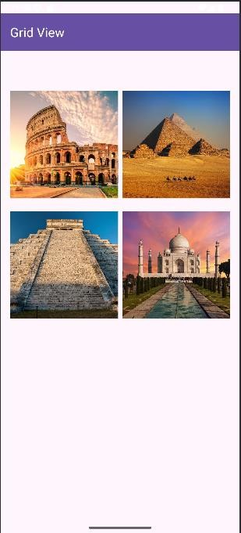
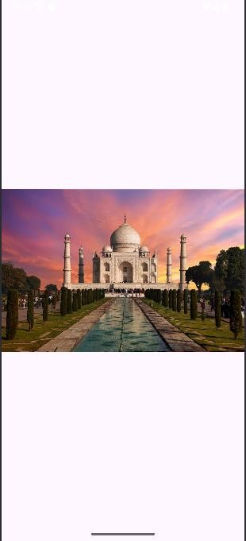

Cognitive (04) | Psychomotor Skill (04) | Affective Domain (02) | Total (10) | Sign

